NLP LAB PROGRAMS

Q1: Regular Expression Pattern Generation
Student details were analyzed and regex patterns formulated as follows:
Field | Regex Pattern
Email ID | ^[a-zA-Z0-9._%+-]+@[a-zA-Z0-9.-]+\.[a-zA-Z]{2,}$
Mobile Number | ^\+91-\d{10}$
Strong Password | ^(?=.*[A-Z])(?=.*[a-z])(?=.*\d)(?=.*[@#$%^&+=!]).{8,}$
Date of Birth | ^(0[1-9]|[12][0-9]|3[01])/(0[1-9]|1[0-2])/\d{4}$
Register Number | ^\d{2}[A-Z]{4}\d{4}$

Q2: Search for a String
Python Program:
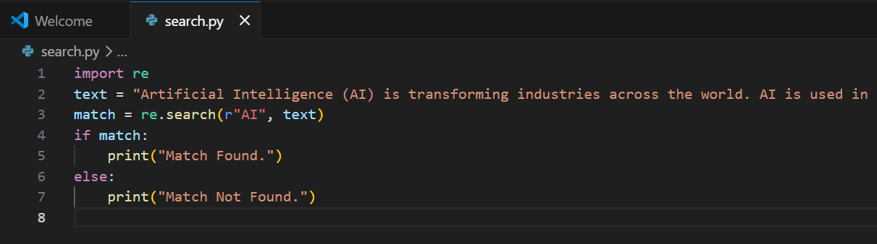
Output: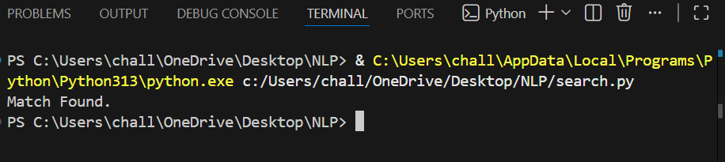

Q3: Split the Documentation into Sentences and Words
Python Program:
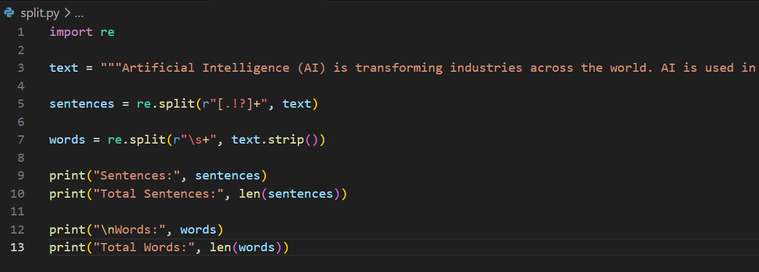
Output:
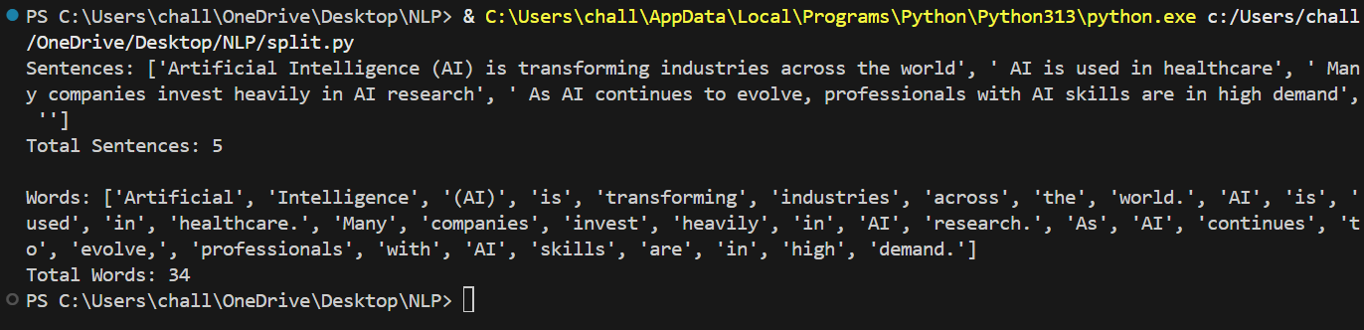

Q4: Email and Strong Password Validation
Python Program:
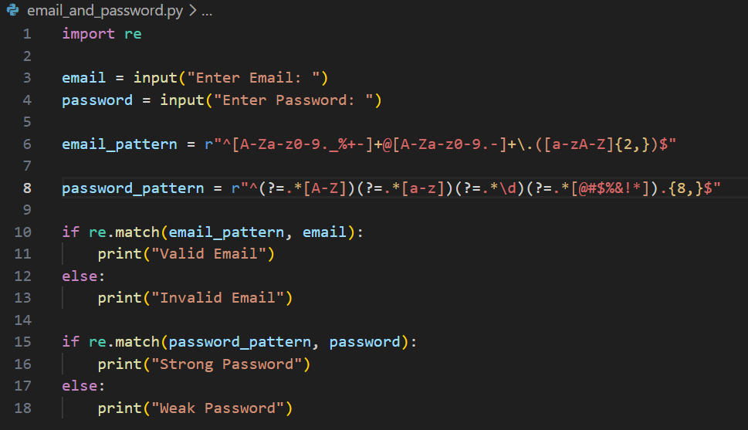
Output:
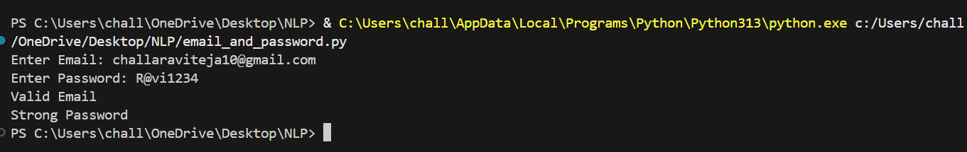

Q5: Compile Once, Validate Many
Python Program:
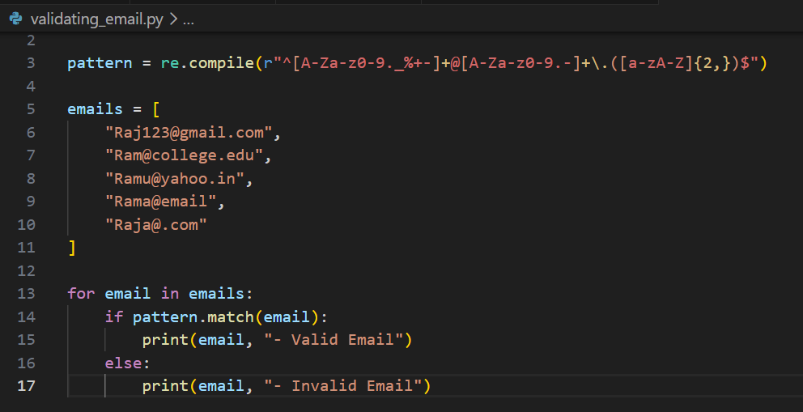
Output:
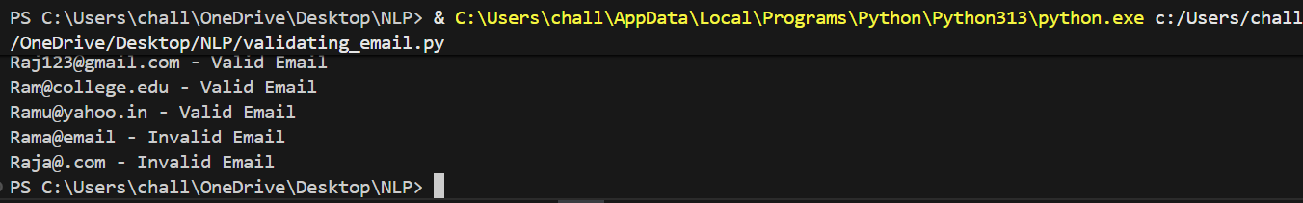

Q6: Singular to plural
Python Program:
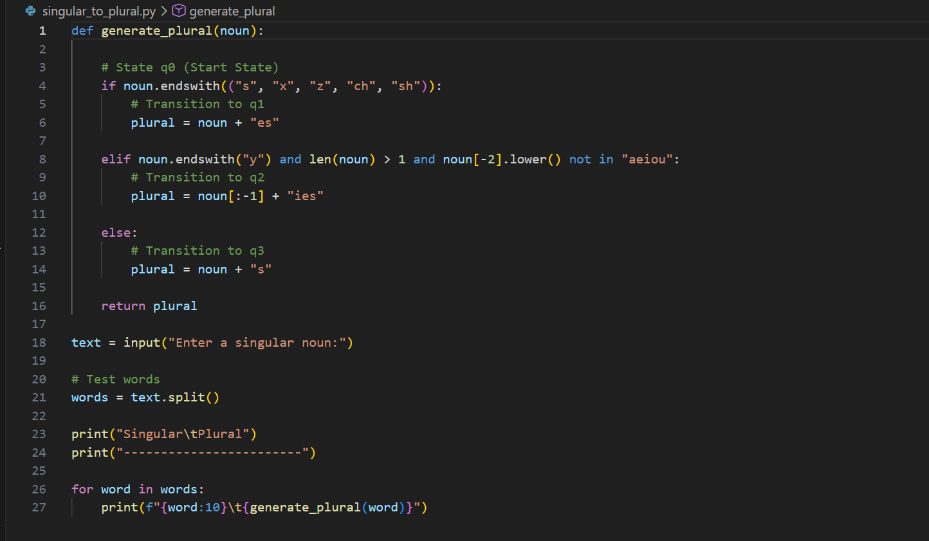
Output:
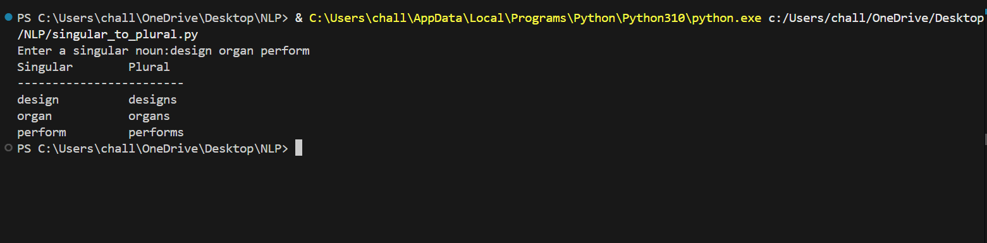

Q7: Validating DFA
Python Program:
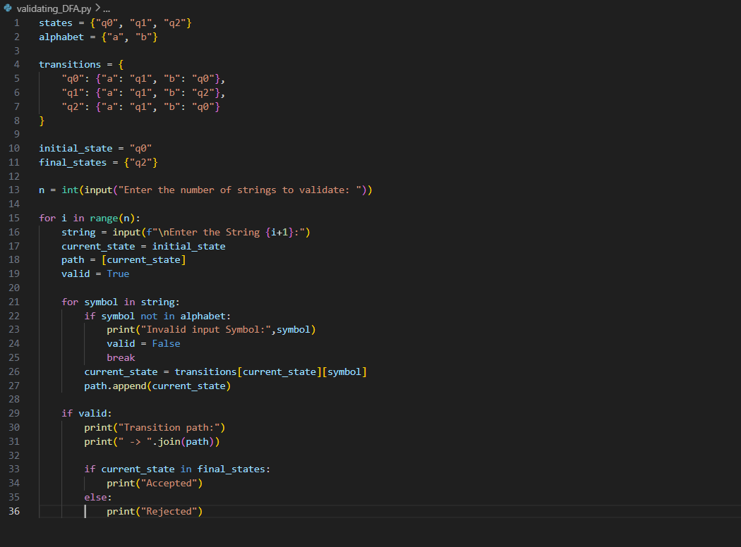
Output:
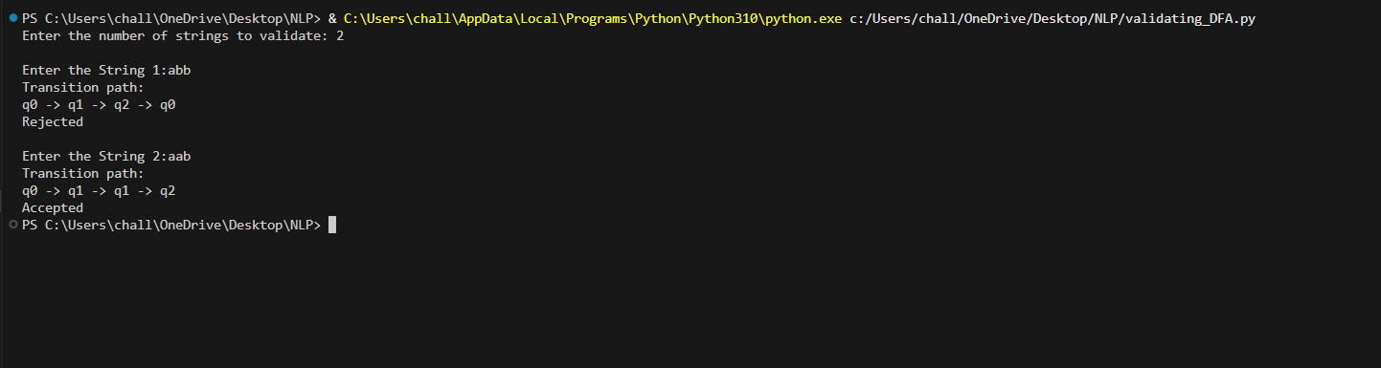

Q8: Word Stemming using Porter Stemmer
Python Program:
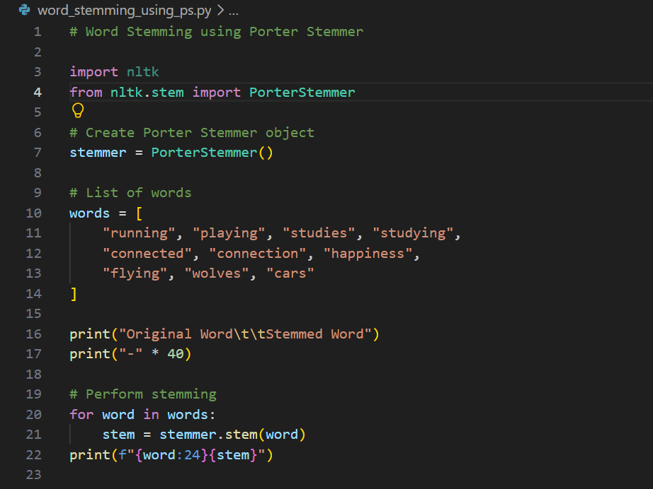
Output:
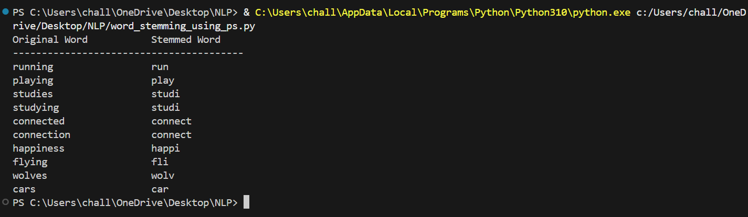

Q9: Morphological Analysis without using Porter Stemmer
Python Program:
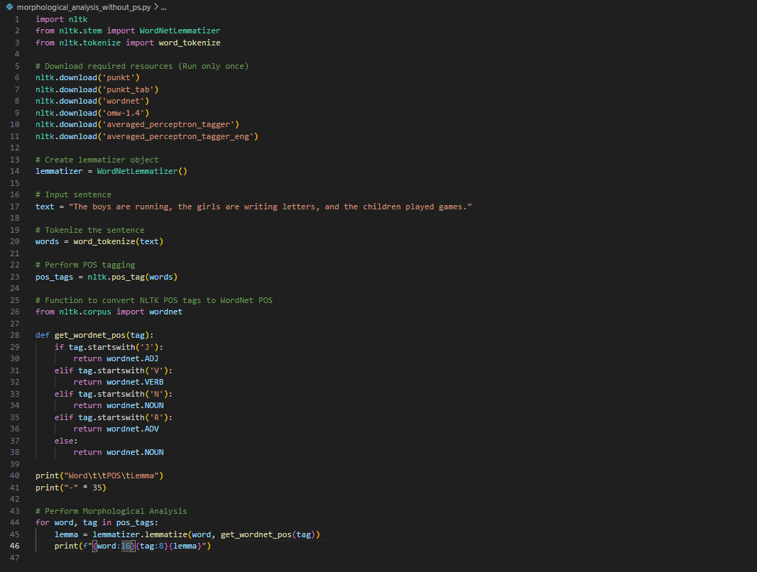
Output:
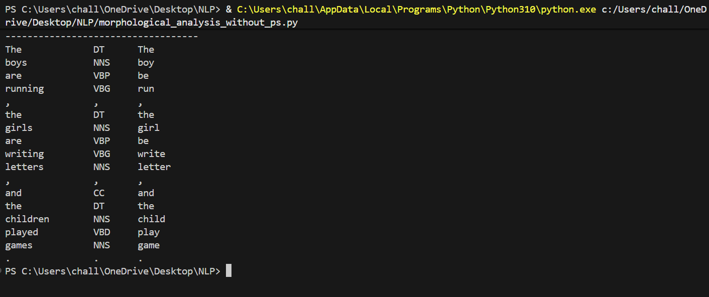

Q10: Porter Stemmer Step 3
Python Program:
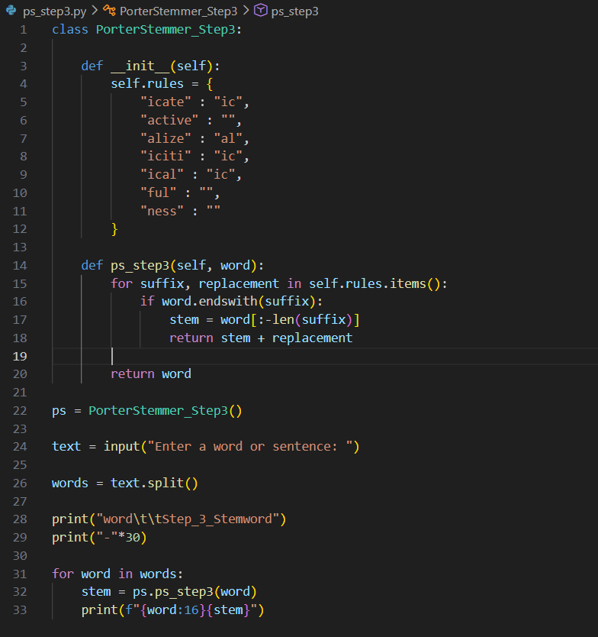
Output:
